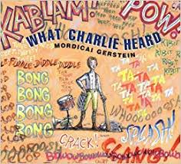

Title: What Charlie Heard

Copyright: 2002

Author: Mordicai Gerstein

I believe this book should be considered a third to fifth grade book because the vocabulary and the story can suggest that it isn’t very hard to read this book also the pictures really help tell a lot of the story so that if you can really read to well you can still kind of understand whats going on based on what you see . The book really is a snapshot of someone’s live it goes from really when he was born to when he dies the book revolves around Charles Ives and his upbringing referring to what his childhood was like for example his child was full of his father teaching him little things about music which then transformed into bigger things like starting to play the drums as a child then it started to shift he was a little kid turning into a teenager and the book really showed all the things he really liked such has music watching his father play music his piano lessons how he would work on interesting compositions with his father. The major rising and falling action begins when Charlies father dies he has to move with his life and start to live a normal life where he graduates college gets married and begins to write music. I think the arts were embedded in some of the vocabulary the book used I think the arts were Imbedded in the illustrations at the whole on every page would have some form of little syllable thing to say like ratatattat or toot toot whoot and I thing this would play an important part in encouraging kids of the younger age to read on their own.

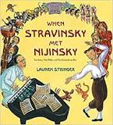

When Stravinsky Met Nijinsky

Lauren Stringer

Copyright 2013

This book is meant for early elementary students because of the extremely large font and how few words there are on each page also the general font is quite large. This story follows the story of when Stravinsky and Nijinsky worked on a Ballet together and how Stravinsky changed to work with the dancers. Both of the main characters worked so hard on making there ballet come together but at the end of the story The music was insane the dancers were stomping and going wild and Stravinsky and Nijinsky both were satisfied because they had created a ruckus and a riot. Some connections that can be made between my arts discipline is the vocabulary used in the story as well as the picture of instruments the pictures in the background were very musically themed. Next another connection can be made with dance and this is true because the dancer Nijinsky the dancing theme came from the collaboration between the musicians and the Dancers ballet.